Version 02-02-2023

Maxi-controller Modbus

Software version 4.0

As of software version 4.0 Modbus is implemented in the Maxi-controller. Before software version 4.0, the Maxi-controller has a proprietary protocol.

Modbus

The Maxi-controller can be monitored and settings can be changed by Modbus.

Modbus type: Modbus RTU
Communication settings: 9600 baud, 8 databits, 1 stop bit, no parity
Responce time: < 200 mS

The Maxi-controller can be monitored by Modbus ‘input registers’.
Input registers can only be read.
The data presented at the input registers are measured data, or actual statuses.

The Maxi-controller can be controlled by Modbus ‘holding registers’.
Holding registers are readable and writable.

Writing to a holding register, is the same as changing parameters by the keyboard of the Maxi-controller.

For reference see the maxi-controller_modbus_registers.xls

Connecting to modbus

Multiple Maxi-controllers can be daisy-chained together or a repeater-box can be used, to connect the Maxi-controllers point to point.
Look if there is an modification inside the repeater box. Or only attach the RS485 signals (pin 7 and 8 of the RJ45). You can blow up the maxi-controller without a modification !!!!

Because of multiple maxi-controllers can be addresses, a slave address has to be set in the Maxi-controller.

Setting modbus address in Maxi-controller

Press ‘set’ to go into ‘Time settings’ menu..
Press ‘+’ 4 times to see ‘Communications’ sub menu
Press ‘set’ You now can set the communication settings with the ‘+’ or the ‘-’ key. Press 2 times ‘+’ to set the modbus address to address 1.


Reading a register

So if you want to see the temperature of room A (Tamb1) you have to read ‘input register 0’

You should request input register 0 with a quantity of 1. The response is 16 bit value which is the temperature.
You can also request more input registers instead of 1. But exceeding the request over the last register, an error will occur. So requesting startaddress = 2, and quantity = 20 will fail. (2 + 20 = 22 end. Last input register is 14 ,so 22 will fail).

If you want to know the percentage steering room 1, you have to read ‘holding register 0’
You should request holding register 0 with a quantity of 1. The response is 16 bit value which is the percentage set (which can not exceed 120)
You can also request more holding registers instead of 1. But exceeding the request over the last register, an error will occur. So requesting startaddress = 2, and quantity = 20 will fail. (2 + 20 = 22 end. Last holding register is 11, so 22 will fail).

Writing a register
Only holding registers can be written to. So changing the room 1 percentage you gave to write to holding register 1.
You can also change more holding registers instead of 1. But exceeding the request over the last register, an error will occur. So requesting startaddress = 2, and quantity = 20 will fail. (2 + 20 = 22 end. Last input register is 14 ,so 22 will fail).

Note.. beware of writing more registers… all registers has to have a valid value…

Modbus master

A handy windows program to test the modbus functionality is ModbusMaster. Can be downloaded at:
https://github.com/ClassicDIY/ModbusTool/releases
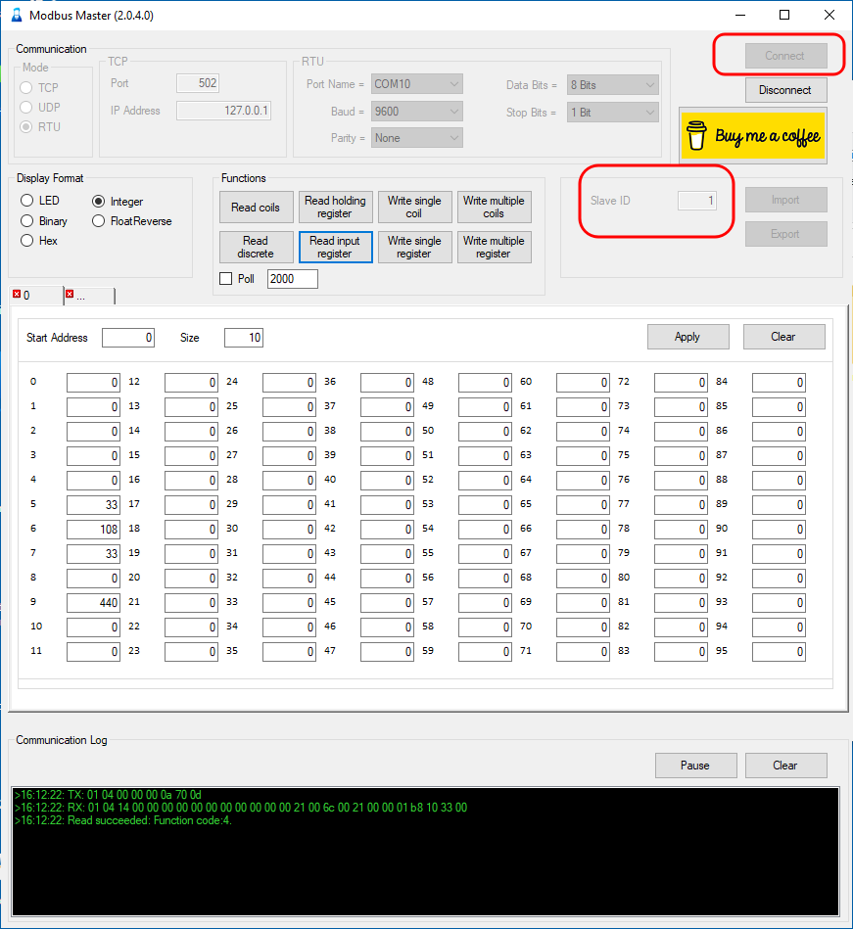

Screenshot of Modbusmaster

Connect the computer with the Repeater, which is connected to a Maxicontroller.
Enter comm settings (baudrate, port name etc.), enter also slave address which is the address of the Maxicontroller. Press connect.
Enter start address (0) en enter quantity (10). Press ‘Read input registers’

Connecting the Maxi-controller
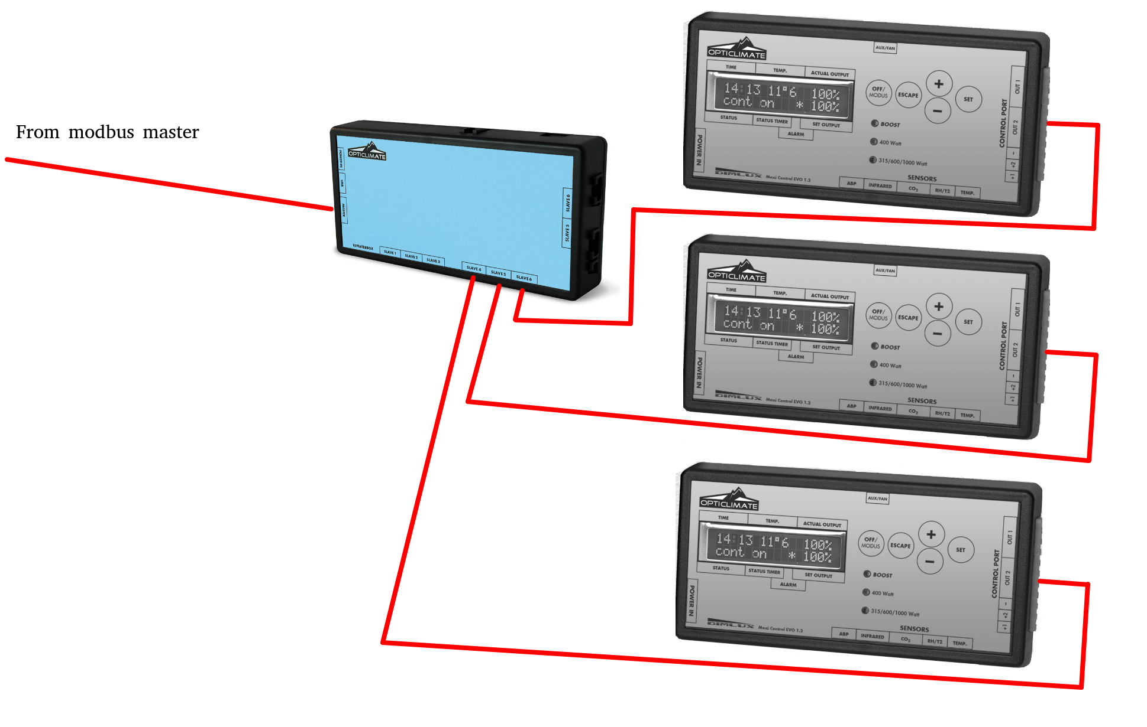
3 Maxi-controllers connected to a repeater.

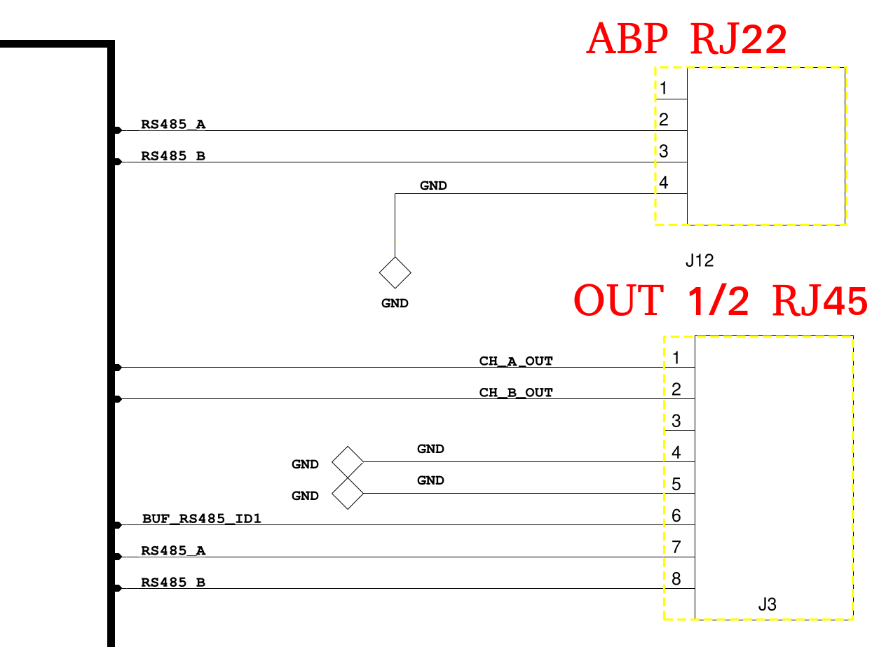

Signals at connectors of the Maxi-controller

